A Prospectus of: The Impact of a Technology Integration

Professional Development Program on

K-6 Student Achievement Indicators
Peter Grostic
December 2015

Definitions
- Student Achievement Metrics – test scores, student attendance, and student behavior referrals.
- Personalized Learning – Learning that allows for differences in pace, evidence of learning, and delivery of content.
Research Problem
Increasing access to supplemental materials, increasing opportunities for personalized learning, and making current practices more efficient for K-12 teachers and students should lead to improved student achievement metrics. According to the United States Department of Education, K-12 students without their own computers or tablets in class may not learn as productively and may not receive as many opportunities for personalized learning as those students with such devices (Future Ready Schools, n.d.). For these reasons, many K-12 schools have chosen to purchase devices for their students to use in class an attempt to increase access to technology. When schools make these purchases, they are engaging in a student device initiative. Student device initiatives can provide for all of the improved learning opportunities listed above. However, the results of such initiatives so far have been inconsistent at best.
Though a number of studies have indicated improvement in student achievement indicators subsequent to implementation of a student device initiative (Bebell & Kay, 2010) research also indicates that student device initiatives in K-12 schools do not consistently improve student achievement metrics. Los Angeles Unified School District (LAUSD) infamously illustrates this fact. LAUSD purchased nearly $1.3 billion worth of iPads for students in 2013, only to halt the program less than two years later due to many issues, including a lack of teacher training (“What Schools Must Learn”, 2015).
Moreover, research on student device initiatives has suffered from a near-exclusive use of test score data to indicate increased academic achievement of students. A focus on student test score data may be masking improvement in other areas of student performance that are key “precursors” of academic achievement. Student achievement metrics certainly include test scores directly. However, research shows that student attendance has a strong positive correlation with test scores (Brown, 2014). Similarly, the number of student behavior referrals has a strong negative correlation with test scores (Mays, 2014). Therefore, gathering data on student attendance and student behavior referrals in addition to initial test scores could paint a clearer picture of the long-term impact of an experimental variable on test scores.

Assumptions
One possible reason that student device initiatives do not consistently improve student achievement metrics may well be due to improper training for teachers and administrators. Joyce and Showers (1981, 2002) make the argument that initial training without follow-up support is virtually valueless. Unfortunately, many K-12 schools’ initial training lacks appropriate follow-up support (Glazer et. al, 2005).
Furthermore, it is hypothesized that the focus of the initial training may be misguided and/or insufficient in three distinct ways. First, the focus may be primarily on how to use the device or how to use a specific program instead of on the purposes for using devices and programs and the advantages that they can provide. Second, training may highlight examples of activities that can be done with the devices and programs instead of highlighting outcomes that can be achieved. Lastly, even if follow-up support is provided, it may be offered too infrequently and may intensify the misguidedness of the initial training. These hypotheses are based on my personal experience as a student device initiative professional development provider and research regarding professional development in general as well as professional development for student device initiatives specifically. Shapley et al. (2010) found that teachers’ quality of student device classroom integration correlated significantly with the quality of professional development provided. Concerning the type of training, Showers (1984) found that coaching for teachers following initial training is essential to ensure new teacher behaviors are implemented in the classroom
Purpose of the Study
The purpose of this study/project is to examine the impact of a professional development program for teachers on the effectiveness of a student device initiative. “Effectiveness” will be defined by student achievement data, as measured by multiple measures of student performance. This study will add to the existent literature on the impacts of student device initiatives in the following ways: (1) It will measure student achievement using a profile of multiple measures to assess change in several, interrelated components of student performance behavior, and, (2) It will examine the impact of providing teachers a professional development program that is explicitly designed to address the weaknesses described above, such as: (i) a focus on how to use devices rather than why devices should be used, (ii) highlighting activities rather than possible outcomes, and (iii) inconsistent follow-up support.

Significance of the Study
The following reasons detail why the inconsistent outcomes from student device initiatives may be a problem. First, taxpayer dollars or private donations are spent with an expectation that student device initiatives will boost student achievement metrics. In the absence of such a boost, the funds spent on the initiative may be seen, by some, as wasted. This may lead to an increase in the rate of rejection for similar future funding proposals. Second, when student device initiatives fail to improve student achievement metrics, they are often abandoned, causing K-12 schools to miss out on less visible benefits that student device initiatives may provide. For example, student device initiatives have been shown to increase levels of student engagement and interest (Bebell & O’Dwyer, 2010).
Consequently, this study will be significant in two ways. First, by including a profile/portfolio of student performance indicators, this study is more likely to detect changes/increases in student performance and behaviors that are strongly linked to academic achievement. Thus, this study may be able to both provide important information on the impact of student device initiatives on key components of student academic performance, as well as serve as a model for future evaluations of technology initiatives. Second, by looking for the differences in student performance impacts between two schools involved in a device initiative with only minimal professional development for teachers, and one with a well-designed professional development program, the study may be able to provide important information regarding the effect and value of such professional development programs. This information could be valuable for helping to understand the impacts that technology initiatives may have on student performance, as well as the value provided by well-designed teacher development programs on the effectiveness of such initiatives. Such findings may provide information that could significantly change our understanding of the importance, and cost-effectiveness, of well-designed professional development programs in supporting the effective use of technology to enhance student learning and achievement.

Literature Review
The potential for gains from student device initiatives in K-12 schools is well documented. Bebell and Kay (2010) found that students who used devices more in class than their counterparts in other classes scored higher on 8th grade assessments in both math and science. Likewise, a study by Gulek and Demirtas (2005) found that students who used devices scored higher in language arts and mathematics assessments than students who did not use devices. Additionally, as mentioned above, student device initiatives can yield higher levels of student engagement and motivation (Bebell & O’Dwyer, 2010).
Obviously, the results of LAUSD’s student device initiative would seem to contradict the studies just referenced. One explanation could be the impact of teacher training and the type of training provided. Shapley et al. (2010) found that teachers’ quality of student device classroom integration correlated significantly with the quality of professional development provided. Concerning the type of training, Showers (1984) found that coaching for teachers following initial training is essential to ensure new teacher behaviors are implemented in the classroom.

Research Question
Does an orientation program and follow-up coaching for K-12 student device initiatives improve student achievement metrics? Answering this question could provide K-12 districts with a model for supporting these types of initiatives and maximizing the program’s potential. The lack of consistency in improving student achievement metrics may be due to the lack of consistent support and professional development for teachers. This study could help provide consistency by showing schools what successful support can look like.
General Research Plan
The experimental group will be Moon Elementary, a K-6 school in the Muskegon Public Schools district in Muskegon, Michigan. The control group will be Lakeside Elementary and Oakview Elementary, two K-6 schools in the same district with similar populations and similar access to technology (Table 1).

Table 1
Relevant descriptors of Moon, Oakview, and Lakeside Elementary Schools
School | Enrollment | Student Demographics | Technology Access
Moon | 402 | African-American - 67%  Hispanic - 8%  Multiracial - 4%  White - 19% | - 1 cart of 30 Android tablets per grade level (K-1)  - 1 cart of 30 Chromebooks per grade level (2-6)
Oakview | 534 | African-American - 57%  Hispanic - 14%  Multiracial - 4%  White - 25% | - 1 cart of 30 Android tablets per grade level (K-1)  - 1 cart of 30 Chromebooks per grade level (2-6)
Lakeside | 592 | African-American - 30%  Hispanic - 14%  Multiracial - 6%  White - 48% | - 1 cart of 30 Android tablets per grade level (K-1)  - 1 cart of 30 Chromebooks per grade level (2-6)

Moon Elementary teachers went through Transformation Orientation (Appendices A and B) and Shoulder to Shoulder Coaching (Appendix C). At the end of the 2015-16 school year, a comparison of student achievement data will be done between the experimental group and the control group. The data analyzed will include test scores (Northwest Evaluation Association (NWEA) Measures of Academic Progress (MAP) data and Fountas and Pinnell (F&P) reading data for grades K-6), student behavior referrals, student attendance, and teacher attendance. When available, data from the last three school years will be used to better isolate the experimental variable(s). The data can then be broken down by each student achievement metric, test score type, and grade level in an attempt to gauge the impact of the experimental variable(s).
Anticipated Difficulties and Pitfalls
It is very difficult to isolate variables. For example, if our treatment school shows any significant differences in any of the data measures, we can’t establish causal connections, only correlates. It could be that some other variable contributed, i.e. a different collection of students, a new teacher, a separate initiative, or a different administrator. These other variables can be minimized be using control schools that have roughly the same inputs and initiatives. However, at best we can only establish correlations between our treatment and any significant difference in outcomes.
Additionally, the frequency of follow-up coaching could impact the results. For example, if no significant improvement in student achievement metrics is found for our experimental group, it may be that the follow-up coaching did not occur often enough. Furthermore, even if a significant improvement in student achievement metrics is shown, it will be impossible to tell if the improvement would have changed significantly with more of less follow-up coaching. With little precedent for follow-up coaching with student device initiatives to point to, it is difficult to gauge the appropriate amount at this time.
Anticipated Benefits
This study could help to solidify research from Joyce and Showers that follow-up coaching in addition to orientation programs is effective professional development for K-12 teachers. Additionally, this study could be the first of its kind to show that an orientation program with follow-up coaching is effective for K-12 student device program implementation. Taking the difficulties of the student into account, additional research could be done to focus the treatment variable(s) even further. However, the general model could be replicated quickly and provide immediate benefits to K-12 schools and districts that are beginning student device implementation programs.

References
Bebell, D. & Kay, R. (2010). One to one computing: A summary of the quantitative
results from the Berkshire Wireless Learning Initiative. Journal of Technology,
Learning, and Assessment, 9(2). Retrieved from http://www.jtla.org.
Bebell, D. & O’Dwyer, L.M. (2010). Educational outcomes and research from
1:1 computing settings. Journal of Technology, Learning, and Assessment, 9(1).
Retrieved from http://www.jtla.org.
Brown, E. (2014). D.C. test data show link between attendance, performance. Retrieved from https://www.washingtonpost.com/local/education/dc-test-data-show-strong-link-between-attendance-performance/2014/05/02/77d1f648-d21f-11e3-a6b1-45c4dffb85a6_story.html
Future Ready Schools: Building Technology Infrastructure for Learning | Office of
Educational Technology. (n.d.). Retrieved January 06, 2016, from http://tech.ed.gov/futureready/infrastructure/
Glazer, E., Hannafin, M. J., & Song, L. (2005). Promoting technology integration through
collaborative apprenticeship. ETR&D Educational Technology Research and
Development, 53(4), 57-67.
Gulek, J . C. & Demirtas, H. (2005). Learning with technology: The impact of laptop use
on student achievement. Journal of Technology, Learning, and Assessment, 3
(2). Retrieved from http://www.jtla.org
Joyce, B., and Showers, B. (2002). Student achievement through staff development
(3rd ed.). Alexandria, VA: Association for Supervision and Curriculum Development.
Joyce, B. R., & Showers, B. (1981). Transfer of training: The contribution of "coaching.".
Journal of Education, 163(2), 163-172. Retrieved from http://search.proquest.com/docview/63653629?accountid=15099
Mays, M. (2014) Report links discipline to test scores in W. Va. Retrieved from http://csgjusticecenter.org/youth/media-clips/report-links-discipline-to-test-scores-in-w-va/
Shapley, K.S., Sheehan, D., Maloney, C., & Caranikas-Walker, F. (2010). Evaluating the
Implementation fidelity of technology immersion and its relationship with student achievement. Journal of Technology, Learning, and Assessment, 9(4).
Showers, B. (1984). School improvement through staff development: The coaching of
teaching Retrieved from http://search.proquest.com/docview/63348993?accountid=15099
What Schools Must Learn From LA’s iPad Debacle. (2015). Retrieved August 15, 2015,
from http://www.wired.com/2015/05/los-angeles-edtech/

Appendix A

Transformation Orientation Program Outline
During the two-day training event, teachers will:
- Review and analyze the Instructional Transformation Matrix (ITM, Appendix B).
- Discuss modern skills for success based on the work of Tony Wagner, author of The Global Achievement Gap.
- Explore learning management systems, digital formative assessment tools, screencasting tools, and blended learning strategies.
- Explore how to work with classroom teachers on the integration of technology into the curriculum and on articulating personal, measurable goals derived from the ITM.
- Create lessons, assessment, find and organize digital content to be used in the upcoming school year.
- Collaboration, communicate, and create lessons within grade level/content area groups to be implemented in the upcoming school year.

Appendix B

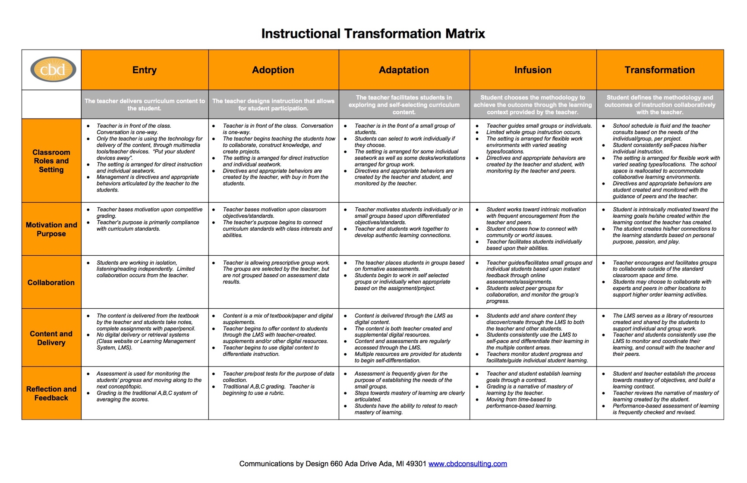
Instructional Transformation Matrix (ITM)

Appendix C

Shoulder to Shoulder Coaching Model
Frequency:
- 14 full-day visits throughout the school year
- Additional follow-up conversations via phone and/or email
Formats:
- 1 all-staff professional development session mid-year
- 4 days of participation in grade-level meetings focused on instructional goals
- 1 day of co-teaching or model teaching in classrooms
- 8 days of individual meetings with teachers
  - Meetings are 30-60 minutes in length
  - Substitute teachers cover classrooms during each meeting
Objectives:
- Support teachers in:
  - Setting and achieving goal(s) along the ITM
  - Training on specific digital programs or apps
  - Training on physical devices used in the classroom
- Hold teachers accountable to working toward goals that were set during Transformation Orientation
- Support administrators in establishing a building-wide digital platform for conveying and discussing pertinent information
- Support communication between teachers regarding student device initiative strategies, successes, and obstacles

